EthernetLite Specification

## 功能介绍

完成以太网的数据链路层功能。对外通过MII接口结合物理层phy芯片通信，对内通过ICB总线和cpu的IP层软件协议进行通信。并能够产生中断信号被PLIC模块接收。

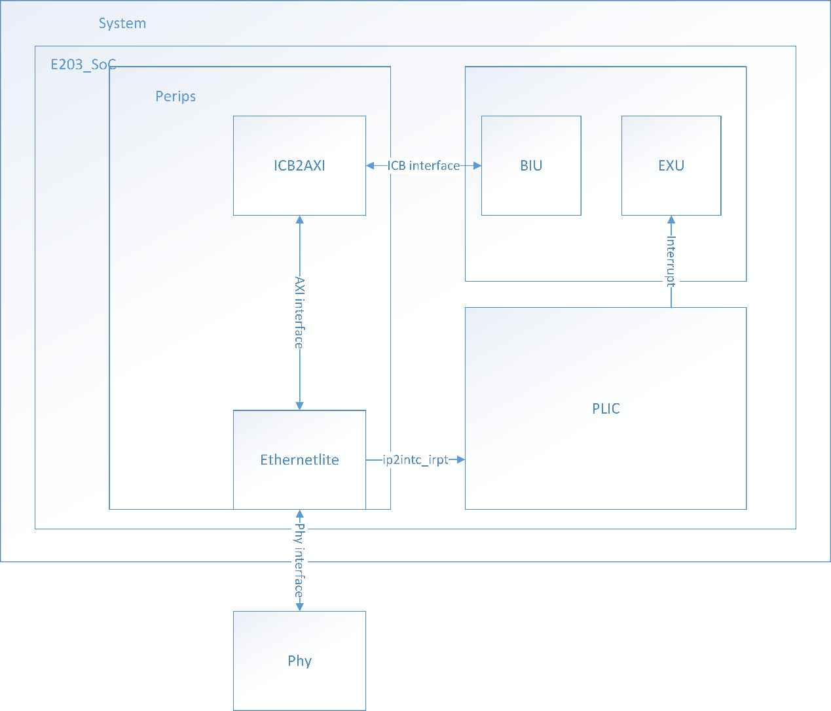

## IO定义

|  |  |  |  |
| --- | --- | --- | --- |
| Name | Direction | Bits | Description |
| Cmd_valid | I | 1 | 主设备发送读写请求 |
| Cmd_ready | O | 1 | 从设备返回读写接收信号 |
| Cmd_read | I | 1 | 读或者写操作指示 |
| Cmd_addr | I | 32 | 读写地址 |
| Cmd_wdata | I | 32 | 写操作数据 |
| Cmd_wmask | I | 3 | 写操作字节掩码 |
| Rsp_valid | O | 1 | 从设备发送读写反馈请求信号 |
| Rsp_ready | I | 1 | 主设备返回读写反馈接收信号 |
| Rsp_rdata | O | 32 | 读反馈数据 |
| ip2intc_irpt | O | 1 | 上升沿触发的中断信号 |
| Phy_tx_clk | I | 1 | 发送时钟来自phy芯片 |
| Phy_rx_clk | I | 1 | 接收时钟来自phy芯片 |
| Phy_rx_data | I | 4 | 来MII接口的接收数据 |
| Phy_tx_data | O | 4 | 向MII接口发送的数据 |
| Phy_dv | I | 1 | 接收数据有效 |
| Phy_rx_er | I | 1 | 接收数据出错 |
| Phy_tx_en | O | 1 | 发送数据使能 |
| Phy_mdc | O | 1 | MDIO接口时钟 |
| Phy_mdio_i | I | 1 | MDIO接口输入数据 |
| Phy_mdio_o | O | 1 | MDIO接口发送数据 |
| Phy_mdio_t | O | 1 | MDIO接口使能输出 |

## 地址映射

发送缓冲区是从0x1500_0000到0x1500_07FF的位置

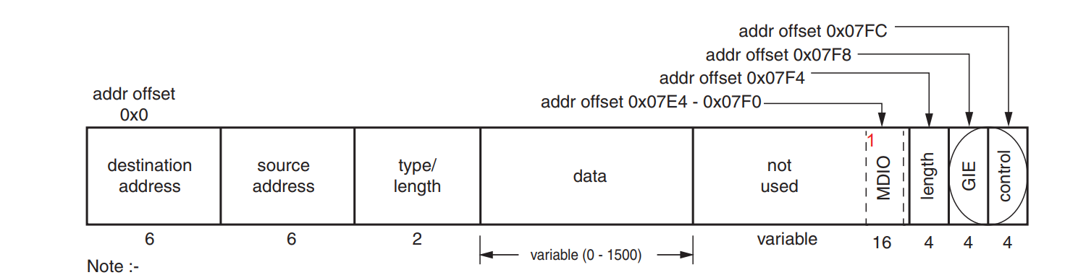

接收缓冲区是从0x1500_1000到0x1500_17FF 的位置

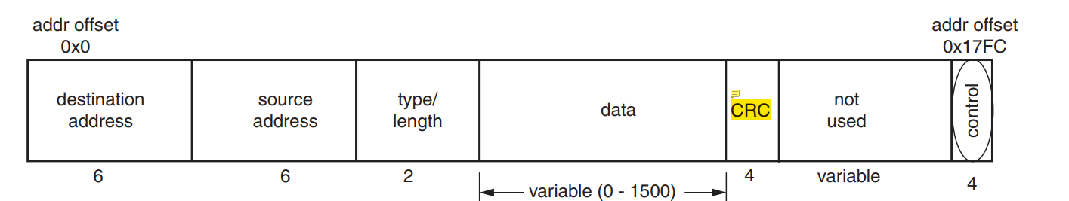

寄存器表

|  |  |  |
| --- | --- | --- |
| **Address Offset** | **Register Name** | **Description** |
| 1500_07E4h | MDIOADDR (1) | MDIO address register |
| 1500_07E8h | MDIOWR (1) | MDIO write data register |
| 1500_07ECh | MDIORD (1) | MDIO read data register |
| 1500_07F0h | MDIOCTRL (1) | MDIO control register |
| 1500_07F4h | TX Ping Length | Transmit length register for ping buffer |
| 1500_07F8h | GIE | Global interrupt register |
| 1500_07FCh | TX Ping Control | Transmit control register for ping buffer |
| 1500_0FF4h | TX Pong Length (2) | Transmit length register for pong buffer |
| 1500_0FFCh | TX Pong Control (2) | Transmit control register for pong buffer |
| 1500_17FCh | RX Ping Control | Receive control register for ping buffer |
| 1500_1FFCh | RX Pong Control (3) | Receive control register for pong buffer |